Wamp practical

Html code and save it with .html extension

<html>

<head>

<title>

Forms

</title>

</head>

<body>

<font size=5>

<form method="post" action="http://localhost/prachiweb/web2.php">

Enter font<input type="text" name="fname"><br><br>

Enter backgroundcolor<input type="text" name="bcolor"><br><br>

Enter string<input type="text" name="str"><br><br>

<input type="submit"/>

</form>

</body>

</html>

Php code and save it with .php extension

<font size=7>

<?php

$f=$_POST["fname"];

$c=$_POST["bcolor"];

$s=$_POST["str"];

echo"<body bgcolor=$c><font face=$f size=6>$s</font>";

?>

Note:save those file where you created your folder in Wamp

Open browser and type localhost and then enter after copy the path of php file and paste it in html

O/p:

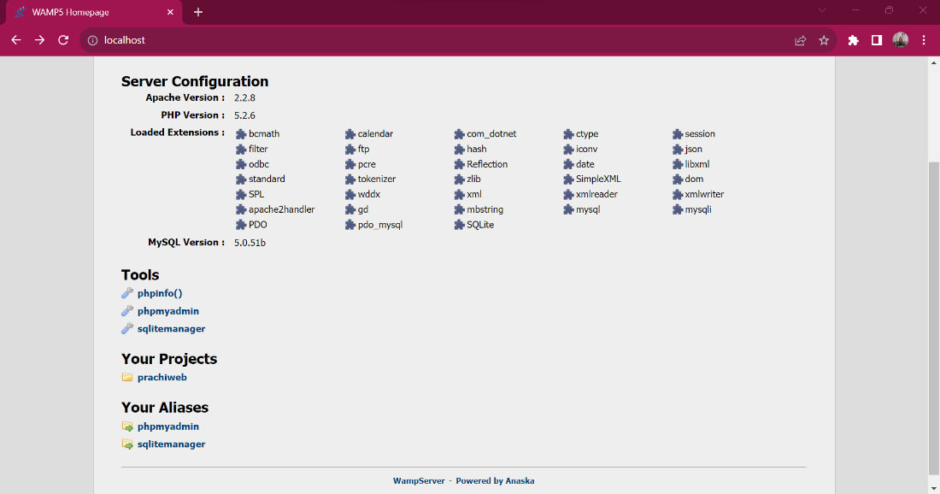

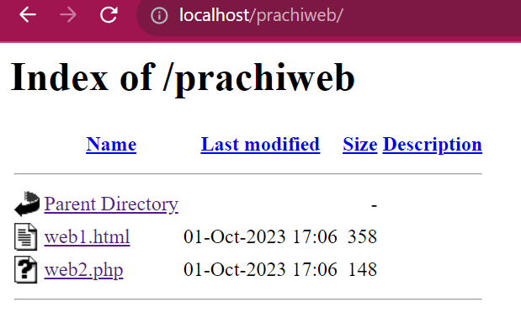

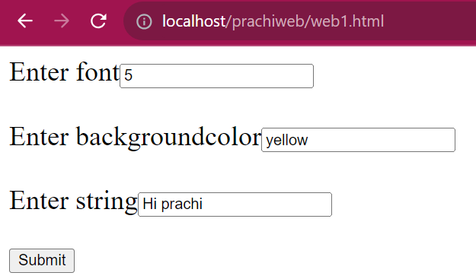



2.factorial of number

<!doctype html>

<html>

<head>

<title>Loops</title>

</head>

<body>

<font size="5">

<?php

$n = 5;

$f = 1;

while($n > 0)

{

$f = $f * $n;

$n = $n - 1;

}

echo "factorial is ". $f;

?>

</font>

</body>

</html>

Save by .php extension

Op:



2.fibonacci

<html>

<head>

<title>Fibonacci </title></head>

<body>

<font size=5>

<?php

$var1 = 0;

$var2 = 1;

$var3;

$sum = 10;

echo($var1."<br/>");

echo($var2."<br/>");

for($i=3;$i<=$sum;$i++)

{

$var3 = $var1 + $var2;

$var1 = $var2;

$var2 = $var3;

echo($var3."<br/>");

}

? >

</font>

</body>

</html>

Op:

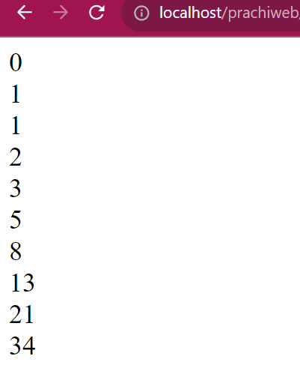

3.prime no

Code

<!doctype html>

<html>

<head>

<title>Prime Numbers</title>

</head>

<body>

<?php

$limit = 10;

for ($i = 1; $i <= $limit; $i++) {

$c = 0;

for ($j = 1; $j <= $i; $j++) {

if ($i % $j == 0) {

$c++;

}

}

if ($c == 2) {

echo $i . "<br>";

}

}

?>

</body>

</html>

Op:

